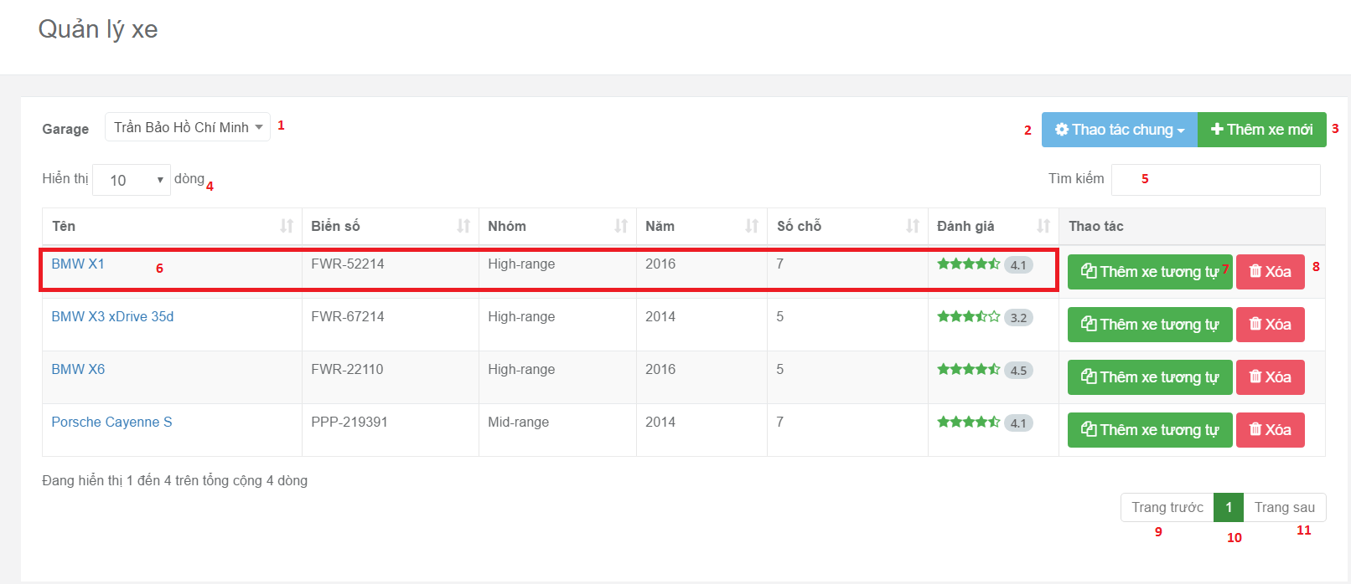

**Fields:**

|  |  |  |  |  |  |  |
| --- | --- | --- | --- | --- | --- | --- |
| No | Field Name | Description | Read Only | Mandatory | Control Type | Data Type |
| 1 | Garage name | Filter vehicle belong to garage | Yes | No | Dropdown | String |
| 2 | Number record in data table | Filter number record be showed in data table | Yes | No | Dropdown | Number |
| 5 | Key search | Filter vehicle belong to key word | No | No | Text Box | String |
| 6 | Specific Record Content | Contain all fields of specific record | Yes | No | Text Box | String |
| 10 | Current Page Of Table | Current page of table | Yes | No | Text Box | String |

**Buttons/Hyperlinks:**

|  |  |  |  |  |
| --- | --- | --- | --- | --- |
| No | Function | Description | Validation | Outcome |
| 2 | Move vehicles to another group or garage. | Show pop up for move vehicles to another. | N/A | Show pop up with 2 action is move to another group or garage. |
| 3 | Create new vehicle | Show pop up for require fields to create a new vehicle | N/A | Show require input field to create a new vehicle. |
| 6 | View detail vehicle’s information | Redirect vehicle detail page | N/A | Show information of vehicle. |
| 7 | Duplicate vehicle | Create new vehicle with same information. | N/A | Create new vehicle faster |
| 8 | Delete vehicle | Delete vehicle | N/A | Show pop up confirm then delete vehicle |
| 9 | Show Previous Record Of Table | Show previous record of table | N/A | Show previous record of table |
| 11 | Show Next Record Of Table | Show next record of table | N/A | Show next record of table |